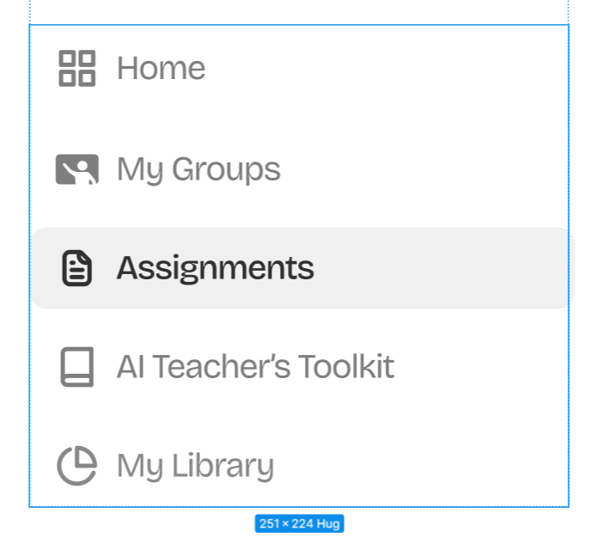Layout details-
width: 251;
height: 224;
gap: 8px;
angle: 0 deg;
opacity: 1;

Home details-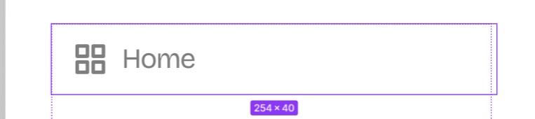layout details- width: 254;
height: 40;
gap: 8px;
angle: 0 deg;
opacity: 1;
border-radius: 8px;
padding-top: 9px;
padding-right: 12px;
padding-bottom: 9px;
padding-left: 12px;

The icon beside home is made up of 4 small boxes.
Icon properties.- Type="fi:grid";
Size="24";
Color="Black";

Icon layout-width: 20;
height: 20;
angle: 0 deg;
opacity: 1;

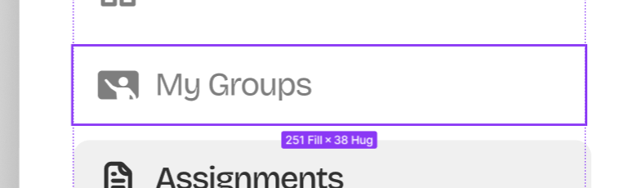
width: 251;
height: 38;

gap: 16px;
angle: 0 deg;
opacity: 1;
border-radius: 8px;

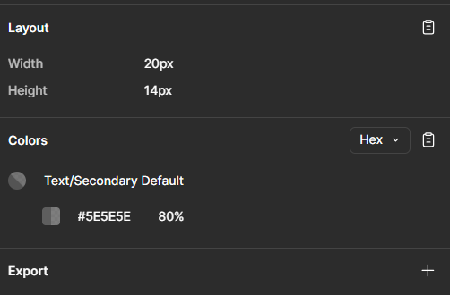
Assignments text details- width: 254;
height: 38;
gap: 8px;
angle: 0 deg;
opacity: 1;
border-radius: 8px;
padding-top: 8px;
padding-right: 12px;
padding-bottom: 8px;
padding-left: 12px;

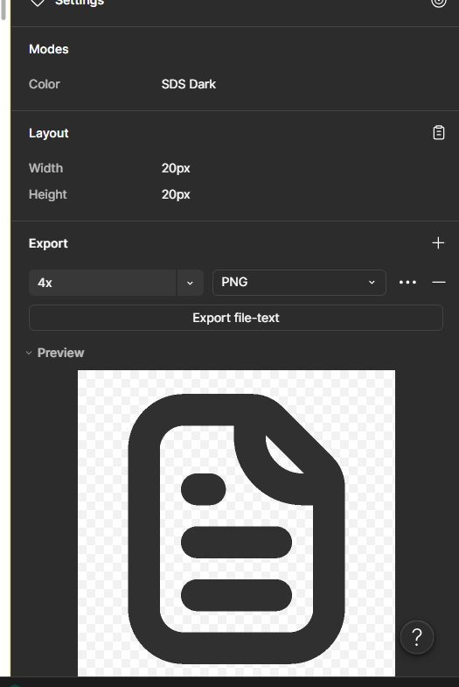



Ai teacher’s toolkit-
width: 254;
height: 38;
gap: 8px;
angle: 0 deg;
opacity: 1;
padding-top: 8px;
padding-right: 12px;
padding-bottom: 8px;
padding-left: 12px;



My library- layout
width: 254;
height: 38;
gap: 8px;
angle: 0 deg;
opacity: 1;
border-radius: Number;
padding-top: 8px;
padding-right: 12px;
padding-bottom: 8px;
padding-left: 12px;



The text font and details
font-family: Bricolage Grotesque;
font-weight: 400;
font-style: Regular;
font-size: 16px;
leading-trim: NONE;
line-height: 140%;
letter-spacing: -4%;
vertical-align: middle;

background: #5E5E5ECC;

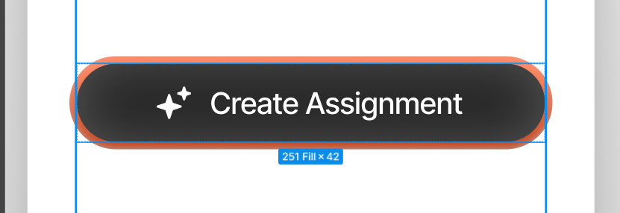Layout details-width: 251;
height: 42;
gap: 10px;
angle: 0 deg;
opacity: 1;
border-radius: 100px;
border-width: 4px;
padding-top: 8px;
padding-right: 43px;
padding-bottom: 8px;
padding-left: 43px;

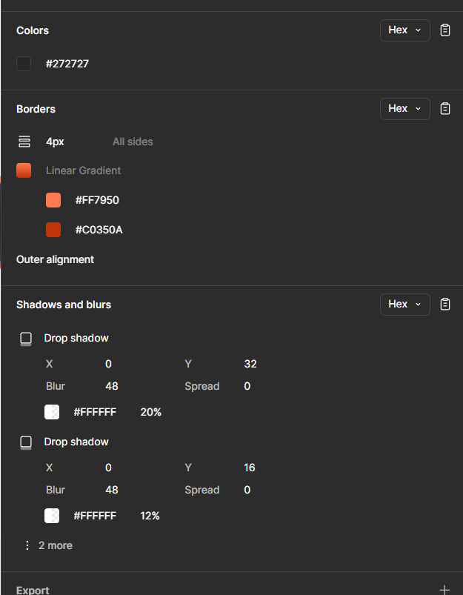colour details.

Logo details-

